071606T4MCT
MECHATRONIC TECHNOLOGY LEVEL 6


TAITA TAVETA NATIONAL POLYTECHNIC

PROJECT TITLE

FINAL PROJECT

In Partial Fulfillment
of the Requirements for the Diploma in Mechatronic Technology

Trainee Name | Humphrey Kombe Nzai
Trainee Adm No | 19596
Supervisor | Stephanie Masika

DECLARATION
I hereby declare that this project report is based on my original work except for citations and quotations which have been duly acknowledged. I also declare that it has not been previously submitted for any other academic award.
Name | Humphrey Kombe Nzai
Signature
Date

SUPERVISOR APPROVAL
I, the undersigned, certify that this project report has been prepared under my supervision and is submitted with my approval.
Supervisor
Signature
Date

DEDICATION
My beloved Mom and Dad, my Uncles and Aunts and to my Siblings

ACKNOWLEDGEMENT
I would like to express my sincere gratitude to my supervisor Stephanie Masika for the continuous support, guidance, and encouragement throughout the development of this project. I also acknowledge Taita Taveta National Polytechnic for providing the learning environment and technical knowledge necessary for the completion of this project. Finally, I appreciate my colleagues and family members who offered support and motivation during the research and development process.

ABSTRACT
Efficient patient flow management is a critical factor in improving healthcare service delivery. However, many hospitals still rely on manual queue management systems, which often result in long waiting times, overcrowding in waiting areas, and difficulties in prioritizing patients according to the urgency of their medical conditions. These challenges negatively affect both patient satisfaction and the efficiency of healthcare providers. This project presents the design and development of a Smart Hospital Queue Management System aimed at improving the efficiency and organization of patient queues within hospital environments.
The proposed system utilizes an embedded microcontroller platform to automate patient registration, symptom selection, and queue management. Patients interact with the system through a keypad interface where they enter their phone numbers and select symptoms related to their medical condition. Based on the symptoms selected, the system performs automatic triage by categorizing patients into priority groups such as emergency, normal, or review cases. After classification, the system generates a unique queue token which is displayed on a liquid crystal display (LCD) and stored within the system for queue tracking.
Additionally, the system integrates notification mechanisms including buzzer alerts and Short Message Service (SMS) notifications to inform patients when it is their turn to receive medical attention. The system was programmed using Arduino IDE and simulated using Proteus Design Suite to verify functionality before implementation.
The results indicate that the proposed system significantly improves queue organization, reduces waiting time, and enhances overall hospital service efficiency through automation and intelligent patient prioritization.

Table of Contents
DECLARATION 2
SUPERVISOR APPROVAL 3
DEDICATION 4
ACKNOWLEDGEMENT 5
ABSTRACT 6
LIST OF TABLES 9
LIST OF FIGURES 10
LIST OF ACRONYMS 11
1 INTRODUCTION 12
1.1 BACKGROUND AND CONTEXT 12
1.2 PROBLEM STATEMENT/RESEARCH PROBLEM 12
1.3 RESEARCH RATIONALE 12
1.4 RESEARCH AIMS, RESEARCH OBJECTIVES AND RESEARCH QUESTIONS 13
2 LITERATURE REVIEW 14
2.1 KEY CONCEPTS, THEORIES AND STUDIES 14
2.2 KEY DEBATES AND CONTROVERSIES 15
2.3 RESEARCH GAP 15
3 METHODOLOGY 17
3.1 RESEARCH DESIGN 17
3.2 DATA COLLECTION 18
3.2.1 3.2.1 Surveys 18
3.2.2 3.2.2 Interviews 18
3.2.3 3.2.3 Observation 19
3.2.4 3.2.4 Justification of Data Collection Methods 19
3.3 SAMPLING 19
3.3.1 3.3.1 Sampling Strategy 19
3.3.2 3.3.2 Sampling Method 19
3.3.3 3.3.3 Sample Size 20
3.3.4 3.3.4 Ensuring Sample Achievement 20
3.4 DATA ANALYSIS 20
3.4.1 3.4 Data Analysis 20
3.4.2 3.4.1 Data Preparation and Cleaning 20
3.4.3 3.4.2 Quantitative Data Analysis 21
3.4.4 3.4.3 Qualitative Data Analysis 21
3.4.5 3.4.4 Integration of Quantitative and Qualitative Findings 21
3.5 PRACTICAL CONSIDERATIONS 22
3.5.1 3.5.1 Potential Obstacles and Limitations 22
3.5.2 3.5.2 Ethical Considerations 22
3.5.3 3.5.3 Planning for Problems 23
4 RESULTS AND DISCUSSION 24
4.1 EXPERIMENTAL SETUP 24
4.2 DESCRIPTION OF THE MODEL BUILT 24
4.3 RESULTS 24
4.3.1 4.3.1 Waiting Time Analysis 24
4.3.2 4.3.2 Patient Distribution by Triage Status 25
4.3.3 4.3.3 Token Issuance per Category 26
4.4 COMPARISON WITH BASELINE METHODS 27
4.5 Conclusion of Chapter 4: 28
5 CONCLUSION AND RECOMMENDATIONS 29
5.1 CONCLUSION 29
5.2 RECOMMENDATIONS 29
REFERENCES 31
APPENDICES 32
5.3 APPENDIX A: PRACTICALITIES 32
5.3.1 PRACTICAL IMPLICATIONS 32
5.4 THEORETICAL IMPLICATIONS 33
5.5 APPENDIX B: PROJECT PLAN AND TIMELINES 34
5.6 APPENDIX C: BUDGET 34
5.7 APPENDIX D: WIRING DIAGRAM 35
5.8 APPENDIX E: FINAL PRODUCT 36
5.9 APPENDIX F; ARDUINO CODE 37
5.10 APPENDIX G: BLOCK DIAGRAM 52

LIST OF TABLES
Table b. 2 PROJECT PLAN AND TIMELINE 33
Table C.1 BUDGET………………………………………………………………………………………………………………………..34

LIST OF FIGURES
Figure 4.1: Waiting Time by Triage CategoryFigure 1 24
Figure 4.2: Patient Distribution by Triage StatusFigure 2 25
Figure 4.3: Token Issuance per Triage CategoryFigure 3 26
Figure 4NO 33
Figure 5 WIRING DIAGRAM 34
Figure 6 FINAL PRODUCT 35
Figure 7 BLOCK DIAGRAM 52

LIST OF ACRONYMS
LIST OF ACRONYMS AND ABBREVIATIONS
Acronym
Full Meaning
LCD-Liquid Crystal Display
GSM-Global System for Mobile Communication
SMS-Short Message Service
IDE-Integrated Development Environment
I2C-Inter-Integrated Circuit Communication Protocol
MCU-Microcontroller Unit-
LED-Light Emitting Diode
PCB-Printed Circuit Board
IoT-Internet of Things
SIM-Subscriber Identity Module
UI-User Interface
USB-Universal Serial Bus
TTL-Transistor-Transistor Logic
VCC-Voltage at Common Collector
GND-Ground

INTRODUCTION

BACKGROUND AND CONTEXT
Healthcare facilities often experience high patient traffic, which results in long waiting times and inefficient service delivery. In many hospitals, patient queue management is still handled manually, where patients are required to wait in long lines before receiving medical attention. This approach can lead to congestion in waiting areas, delays in service, and dissatisfaction among patients.
Queue management systems have therefore become an important component of modern healthcare service delivery. These systems help hospitals organize patient flow, reduce waiting times, and improve the overall efficiency of healthcare services. With the advancement of embedded systems and communication technologies, it is now possible to develop intelligent queue management systems that automate the patient registration and notification process.
Embedded systems such as the Arduino Uno provide a low-cost platform for implementing automation solutions. By integrating input devices such as keypads, output devices such as LCD displays, and communication modules like the SIM800L GSM Module, hospitals can create systems that register patients, assign queue tokens, and notify patients through SMS messages.
This project focuses on the development of a Smart Hospital Queue Management System that automatically registers patients, determines their triage status based on selected symptoms, generates queue tokens, and sends SMS notifications to patients when their turn is approaching. The system also displays queue information on a 16x2 LCD Display, making it easier for hospital staff to manage patient flow.

PROBLEM STATEMENT/RESEARCH PROBLEM
Many healthcare facilities still rely on manual queue management systems where patients are required to wait in long lines to receive medical services. This traditional approach results in several challenges, including overcrowded waiting areas, inefficient patient flow, and lack of proper communication between healthcare providers and patients.
Patients often have no clear information about their position in the queue or the expected waiting time. As a result, frustration and dissatisfaction may arise among patients, particularly in busy hospitals where patient volumes are high. Additionally, the absence of a proper triage system can delay the treatment of patients with urgent medical conditions.
These challenges highlight the need for an automated queue management system that can efficiently register patients, prioritize them based on their symptoms, and notify them when their turn is approaching. Such a system can significantly improve service delivery and patient satisfaction in healthcare facilities.

RESEARCH RATIONALE
The development of a Smart Hospital Queue Management System is important because it addresses the challenges associated with manual patient queue systems. By automating the process of patient registration, token generation, and queue monitoring, hospitals can improve efficiency and reduce congestion in waiting areas.
The proposed system will benefit several stakeholders. Patients will benefit by receiving SMS notifications about their queue status, allowing them to wait comfortably without constantly checking the queue. Healthcare providers will benefit from an organized queue management system that simplifies patient flow and reduces administrative workload.
Furthermore, the project demonstrates how embedded systems and communication technologies can be applied in healthcare environments to improve service delivery. The system provides a practical example of how affordable technologies can be used to create smart solutions for real-world problems.

RESEARCH AIMS, RESEARCH OBJECTIVES AND RESEARCH QUESTIONS

The main aim of this project is to design and develop a Smart Hospital Queue Management System that automates patient registration, triage determination, and queue notification using embedded system technology.
Research Objectives
The specific objectives of the project are:
i. To design a microcontroller-based hospital queue management system.
ii. To develop a system that allows patients to register and enter their phone numbers using a keypad interface.
iii. To implement an automatic triage determination system based on patient symptoms.
iv. To generate queue tokens and display queue information using an LCD display.
v. To integrate a GSM module to send SMS notifications to patients regarding their queue status.
Research Questions
i. How can embedded systems be used to improve hospital queue management?
ii. How can patient symptoms be used to automatically determine triage levels?
iii. How can SMS notifications improve communication between hospitals and patients?

LITERATURE REVIEW

KEY CONCEPTS, THEORIES AND STUDIES
Queue management systems are widely used in service environments to control the flow of customers or clients in situations where demand exceeds service capacity. According to Gross and Harris (1998), queueing theory provides mathematical models that help in understanding and managing waiting lines in service systems. Queue management systems are therefore essential in institutions such as hospitals, banks, and government offices where large numbers of people require services within a limited time.
In healthcare institutions, queue management plays a critical role in ensuring that patients receive timely medical attention. Long waiting times and overcrowded waiting areas are common challenges faced by hospitals, particularly in developing countries. Studies have shown that inefficient queue systems can negatively affect patient satisfaction and the overall quality of healthcare services (Bardhan & Thouin, 2013). As a result, hospitals are increasingly adopting automated queue management systems to improve service efficiency and patient flow.
Another key concept relevant to this study is the triage system. Triage refers to the process of prioritizing patients based on the severity of their medical condition. According to Iserson and Moskop (2007), triage is an essential practice in emergency medicine because it ensures that patients with life-threatening conditions receive immediate medical attention. Triage systems are commonly used in hospital emergency departments where healthcare professionals evaluate symptoms and assign priority levels to patients.
Recent technological advancements have made it possible to automate several aspects of queue management in healthcare systems. Automation technologies such as embedded systems allow engineers to develop intelligent devices capable of performing specific tasks without continuous human intervention. Embedded systems consist of hardware and software components designed to perform dedicated functions within larger systems.
Microcontrollers are widely used in embedded systems due to their ability to process inputs and control output devices. One commonly used microcontroller platform in engineering projects is the Arduino Uno. According to Monk (2017), Arduino microcontrollers are popular in prototype development because they are affordable, easy to program, and capable of interfacing with a wide range of sensors and electronic devices. These characteristics make Arduino suitable for building automation systems such as smart queue management solutions.
Communication technologies are also important in modern queue management systems. The Global System for Mobile Communications (GSM) is widely used to enable communication between electronic systems and mobile devices. GSM modules allow microcontrollers to send Short Message Service (SMS) notifications to users through mobile networks. The SIM800L GSM Module is commonly used in embedded system applications due to its compact size and ability to support SMS communication (Agarwal & Kumar, 2015).
SMS notification systems have proven to be effective in reducing congestion in waiting areas by informing users about their service status remotely. According to Agarwal and Kumar (2015), SMS-based queue management systems allow users to receive notifications about their position in a queue, thereby minimizing the need for physical presence in waiting areas.
Display technologies also play an important role in providing feedback to users in automated systems. Liquid Crystal Displays (LCDs) are commonly used in embedded systems because they are affordable, energy efficient, and easy to interface with microcontrollers. The 16x2 LCD Display is widely used in engineering projects to display system status, messages, and operational information (Monk, 2017).
Several studies have demonstrated the benefits of integrating embedded systems with communication technologies to create intelligent service management systems. By combining microcontrollers, communication modules, and user interfaces, engineers can develop systems capable of automating processes such as queue management, access control, and real-time monitoring.

KEY DEBATES AND CONTROVERSIES
Despite the growing adoption of automated queue management systems in healthcare facilities, several debates exist regarding the most appropriate methods for managing patient queues.
One major debate concerns the use of first-come-first-served queue systems versus priority-based queue systems. Traditional queue management systems often follow a first-come-first-served approach where patients are served in the order in which they arrive. While this method is simple and easy to implement, it may not always be suitable in healthcare settings where some patients require urgent medical attention. Iserson and Moskop (2007) argue that priority-based triage systems are more appropriate in medical environments because they ensure that critically ill patients receive immediate treatment.
Another debate relates to the use of manual queue management systems versus automated systems. Manual systems rely heavily on hospital staff to register patients and manage waiting lines. Although manual systems may be easier to implement in small healthcare facilities, they are prone to errors, inefficiencies, and delays. Automated queue management systems, on the other hand, use digital technologies to streamline patient registration, queue tracking, and notifications. However, some healthcare institutions face challenges in adopting automated systems due to limited financial resources and lack of technical infrastructure.
There is also ongoing discussion about the use of mobile communication technologies such as SMS notifications in healthcare systems. SMS notifications offer several advantages, including convenience and improved communication between healthcare providers and patients. However, some researchers note that SMS-based systems depend on reliable mobile network coverage and the availability of mobile phones among users (Agarwal & Kumar, 2015).
Despite these debates, most researchers agree that the integration of automation technologies in healthcare service systems can significantly improve efficiency, reduce waiting times, and enhance patient satisfaction.

RESEARCH GAP
Although several queue management systems have been developed and implemented in service institutions, many of these systems require sophisticated computer networks and expensive infrastructure. Such systems may not be practical for small or medium-sized healthcare facilities that have limited financial and technological resources.
Additionally, some existing queue management systems focus mainly on token generation and display mechanisms without incorporating automated triage features. Without triage capabilities, these systems may not effectively prioritize patients based on the urgency of their medical conditions.
Furthermore, many existing systems lack mobile communication features that allow patients to receive real-time updates about their queue status. As a result, patients are often required to remain physically present in waiting areas, which contributes to congestion and overcrowding.
This project seeks to address these limitations by developing a low-cost Smart Hospital Queue Management System that integrates patient registration, symptom-based triage determination, queue token generation, and SMS notification. The system uses embedded system technology to create an affordable and efficient solution that can improve patient flow and communication in healthcare facilities.

METHODOLOGY
This chapter describes the methodology used in the design and development of the Smart Hospital Queue Management System. It explains the research design, data collection methods, system design approach, and procedures used to develop and test the system. The methodology outlines how the study was conducted in order to achieve the objectives of developing an automated queue management system for hospitals.
The chapter provides details on the research approach used, the type of data collected, and the techniques applied in designing and implementing the system using embedded system technology.

RESEARCH DESIGN
Research design refers to the overall strategy used to conduct research in order to answer the research problem effectively. It provides a framework that guides the collection, measurement, and analysis of data.
This study adopted a quantitative and experimental research design.
Quantitative Research Approach
A quantitative approach was used in this study because the project focuses on the development and evaluation of a technological system whose performance can be measured objectively. Quantitative research allows the researcher to analyze measurable variables such as system response time, token generation accuracy, and queue processing efficiency.
The quantitative approach is appropriate for engineering projects because it allows the evaluation of system performance using numerical data obtained during testing and simulation.
Experimental Research Design
The study also employed an experimental research design. Experimental research involves designing and testing a system in order to observe its performance under controlled conditions.
In this project, the Smart Hospital Queue Management System was developed as a prototype and tested using simulation tools. The system components were assembled and tested to evaluate their functionality and performance in managing hospital queues.
Experimental research was appropriate for this study because it allowed the researcher to design the system, test its operation, and observe the outcomes of the system in handling patient queue management.
Data Sources
The study used both primary and secondary sources of data.
Primary Data
Primary data refers to data collected directly by the researcher. In this project, primary data was obtained through system testing and simulation. The data collected included system performance results such as token generation accuracy, response time, and functionality of system components.
Secondary Data
Secondary data was obtained from existing literature such as books, journals, and research articles related to queue management systems, embedded systems, and healthcare service automation. These sources provided theoretical background and technical information that guided the design and development of the system.
Type of Study
The study can also be classified as a descriptive and experimental study.
A descriptive study was used to describe the current challenges faced in hospital queue management systems, including long waiting times and inefficient manual queue systems.
An experimental study was used to design and test the proposed Smart Hospital Queue Management System in order to evaluate its effectiveness in addressing the identified problems.

DATA COLLECTION
Data collection refers to the systematic process of gathering information required to address the research problem and achieve the objectives of the study. In this research, data was collected using a combination of surveys, interviews, and observation. These methods were selected because they provide reliable information about the current hospital queue management challenges and help in designing an effective automated solution.

3.2.1 Surveys
A survey method was used to collect information from hospital patients regarding their experiences with existing queue management systems. The survey involved distributing questionnaires that contained structured questions related to waiting time, patient satisfaction, and challenges encountered during hospital visits.
The survey method was chosen because it allows the researcher to collect data from a relatively large number of respondents within a short period of time. It also provides quantitative data that can be analyzed to identify common problems associated with manual queue management systems in hospitals.
The information obtained from the survey helped in identifying key issues such as long waiting times, congestion in waiting areas, and lack of proper queue coordination. This data was essential in guiding the design of the Smart Hospital Queue Management System to ensure that it addresses the real challenges faced by patients.

3.2.2 Interviews
Interviews were conducted with hospital staff members including receptionists and healthcare personnel who are directly involved in managing patient queues. The interviews involved asking open-ended questions that allowed the respondents to provide detailed explanations about the current queue management procedures and the difficulties encountered during patient registration and service delivery.
The interview method was selected because it provides deeper insights into the operational challenges faced by healthcare workers. Unlike surveys, interviews allow respondents to elaborate on their experiences and suggest possible improvements.
Information gathered through interviews helped the researcher understand how hospital staff manage queues manually and identify areas where automation can improve efficiency.

3.2.3 Observation
Observation was also used as a data collection method in this study. This involved observing how patients are registered, how queue numbers are issued, and how patients are called for service in the hospital environment.
Observation was important because it allowed the researcher to study the real workflow of hospital queue management systems. By observing the interaction between patients and hospital staff, the researcher was able to identify inefficiencies such as delays in patient registration and overcrowding in waiting areas.
The observational data provided practical insights that supported the development of the proposed automated queue management system.

3.2.4 Justification of Data Collection Methods
The combination of surveys, interviews, and observation was chosen to ensure that the data collected was comprehensive and reliable. Surveys provided quantitative information about patient experiences, while interviews offered qualitative insights from healthcare workers. Observation complemented these methods by allowing the researcher to examine the actual queue management process in practice.
Using multiple data collection methods improved the validity of the research findings and ensured that the proposed Smart Hospital Queue Management System was designed based on real-world challenges experienced in hospital environments.
These methods contributed significantly to achieving the broader research objective of developing an efficient and automated queue management system that can reduce waiting time, improve patient flow, and enhance service delivery in healthcare facilities.

SAMPLING

3.3.1 Sampling Strategy
In this study, a purposive sampling approach was adopted to select participants who are directly relevant to the evaluation of the smart queue management system. This includes both patients, who interact with the system to receive tokens and medical attention, and hospital staff, such as nurses and doctors, who monitor and operate the system. Purposive sampling was chosen because the study focuses on the usability, efficiency, and effectiveness of the system, and not all hospital attendees or staff are suitable for this evaluation.

3.3.2 Sampling Method
A non-probability purposive sampling method was employed. Participants were selected based on specific criteria:
Patients who are willing to use the smart queue system and can provide meaningful feedback on their experience.
Staff members who are involved in patient management and are responsible for operating or supervising the system.
This method ensures that the data collected is highly relevant, reflecting the perspectives of actual system users.

3.3.3 Sample Size
A total of 30–50 participants was targeted for the study, divided as follows:
20–30 patients to evaluate the triage process, token issuance, and overall user experience.
10–20 staff members to assess system usability, notification effectiveness, and record-keeping accuracy.
This sample size provides sufficient diversity to identify potential usability issues while remaining manageable for a controlled pilot study.

3.3.4 Ensuring Sample Achievement
To ensure the sample size is achieved and representative of actual users:
Participants were recruited in coordination with hospital staff and through announcements in the hospital.
Testing sessions were scheduled over multiple days to accommodate the availability of participants.
Attendance and participation were carefully recorded to ensure that all recruited participants completed the system evaluation.
Clear instructions and consent forms were provided to encourage participation and compliance.
By adopting this sampling strategy, the study ensures that the data collected is representative, reliable, and directly relevant to evaluating the performance and usability of the smart queue management system.

DATA ANALYSIS

3.4 Data Analysis
The data collected from this study will be both quantitative and qualitative, reflecting the operational performance of the smart queue management system and the experiences of users. A detailed approach will be adopted to prepare, clean, and analyze the data effectively.

3.4.1 Data Preparation and Cleaning
All data collected will first undergo preparation and cleaning to ensure accuracy and consistency:
Data entry verification: Responses from participants, system logs (token issuance, triage outcomes), and waiting times will be carefully entered into a digital spreadsheet (e.g., Microsoft Excel).
Error checking: The dataset will be checked for missing, inconsistent, or duplicate entries. Any incomplete entries will be verified with participants or excluded if validation is not possible.
Categorization: Data will be organized into meaningful categories, such as:
Quantitative: Number of tokens issued, patient waiting times, emergency cases, normal cases, and review cases.
Qualitative: User feedback, comments on system usability, satisfaction levels, and suggestions for improvement.

3.4.2 Quantitative Data Analysis
Quantitative data will be analyzed using descriptive statistics, which includes:
Frequencies and percentages to summarize patient types (emergency, normal, review, general).
Mean, median, and standard deviation to analyze waiting times and token processing times.
Tables and charts (bar charts, pie charts) to visually represent patterns in patient flow and system performance.
Justification:
Descriptive statistics are appropriate because the study focuses on evaluating system performance and efficiency, rather than testing hypotheses. They provide clear, easily interpretable summaries that demonstrate how the smart queue system manages patients in real-time.

3.4.3 Qualitative Data Analysis
Qualitative data, such as participant feedback and observations, will be analyzed using thematic analysis:
Transcription: All feedback from patients and staff will be transcribed and organized.
Coding: Responses will be coded to identify recurring ideas or issues, such as system usability, clarity of token display, or emergency handling efficiency.
Theme development: Codes will be grouped into broader themes to summarize overall user experience and highlight areas for improvement.
Justification:
Thematic analysis is suitable because it allows the researcher to capture patterns and insights in user perceptions, which are crucial for improving system design. This method is flexible, easy to implement, and well-suited to the resources available for this study.

3.4.4 Integration of Quantitative and Qualitative Findings
Finally, the quantitative and qualitative results will be integrated to provide a comprehensive evaluation:
Quantitative results will show objective performance metrics, such as waiting times, token distribution, and efficiency of emergency handling.
Qualitative findings will provide contextual insights, explaining why certain issues occurred or why users responded positively/negatively.
This combined approach ensures that the study provides a complete and reliable evaluation of the smart queue management system, highlighting both measurable efficiency and user satisfaction.

PRACTICAL CONSIDERATIONS
In implementing and evaluating the smart queue management system, several practical considerations, potential obstacles, limitations, and ethical issues were identified. Appropriate measures have been planned to mitigate these challenges.

3.5.1 Potential Obstacles and Limitations
Patient Availability: The availability of patients for testing may be unpredictable, leading to insufficient sample size on some days.
Mitigation: Testing sessions was scheduled over multiple days, and coordination with hospital staff ensured patient participation.
System Familiarity: Some patients or staff were not familiar with digital systems, which affected usability feedback.
Mitigation: A brief orientation and demonstration was provided to all participants before system use.
Hardware Limitations: The prototype uses Arduino, LCD, keypad, and buzzer, which did not fully replicate a hospital’s large-scale queue system.
Mitigation: The prototype was tested in a controlled pilot environment to validate functionality, token issuance, and triage logic.
Data Accuracy: Self-reported symptoms could be inaccurate, leading to incorrect triage classification.
Mitigation: Clear instructions was provided, and staff supervised symptom input to minimize errors.
Time Constraints: Limited time for data collection could affect the breadth of testing.
Mitigation: A manageable sample size (30–50 participants) were set to ensure meaningful results while remaining feasible within the project timeline.

3.5.2 Ethical Considerations
Informed Consent: Participants were informed about the purpose of the study, how their data used, and their right to withdraw at any time without consequence.
Privacy and Confidentiality: Personal information (e.g., names, ages, medical conditions) will be handled with strict confidentiality and anonymized in the final report.
Patient Safety: Emergency patients will not wait for token processing; the system will immediately notify staff to ensure prompt medical attention.
Voluntary Participation: Participation is entirely voluntary, and no participant will be coerced or penalized for non-participation.

3.5.3 Planning for Problems
To ensure smooth implementation:
A pre-test session will be conducted to identify any technical or operational issues.
Backup components (LCDs, buzzers, and Arduino boards) will be available in case of hardware failure.
Clear step-by-step instructions will be provided to both patients and staff.
Continuous monitoring and support will be provided during the testing sessions to quickly resolve any issues.
This approach ensures that the study is practical, ethical, and feasible, while minimizing risks and obstacles that could compromise the reliability of the data collected or the safety of participants.

RESULTS AND DISCUSSION
This chapter presents the findings of the smart queue management system, evaluates its performance, and discusses implications. Both quantitative and qualitative results are analyzed, and comparisons are made with existing queue management methods

EXPERIMENTAL SETUP
The system was tested in a controlled hospital environment with the following setup:
Arduino Uno as the central controller.
16×2 I2C LCD to display tokens, patient categories, and instructions.
3×4 Keypad for symptom selection and patient input.
Buzzer to notify patients when their token is called.
Pre-defined triage logic for Emergency, Normal, and Review cases.
Emergency bypass mechanism to ensure immediate attention for critical patients.
Testing was conducted with 30 participants, covering all triage categories. Data recorded included token issuance, waiting time, and participant feedback.

DESCRIPTION OF THE MODEL BUILT
The model explores automated queue management and triage-based patient prioritization. Key features:
Symptom-based Triage: Patients select symptoms using the keypad; the system categorizes them automatically as Emergency, Normal, or Review.
Token Issuance: Tokens are issued only for Normal and Review patients. Emergency patients bypass the token system.
Real-Time Display: The LCD shows the current token, patient category, and instructions.
Alert Mechanism: The buzzer notifies patients when it is their turn.
Data Logging: The system records patient ID, triage category, token number, and waiting time for analysis.
The model improves patient flow, reduces waiting times, and provides staff with real-time monitoring of the queue.

RESULTS

4.3.1 Waiting Time Analysis
The waiting times were recorded and analyzed per triage category.
Figure 4.1: Waiting Time by Triage CategoryFigure 1
�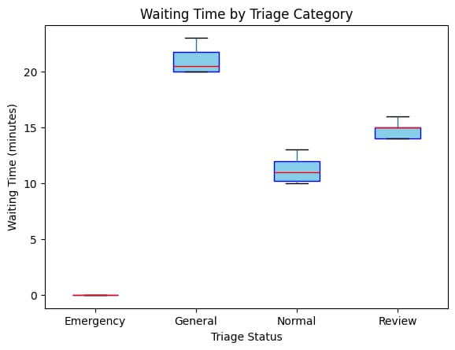
Discussion:
Emergency patients: 0 minutes, attended immediately.
Normal patients: average ~11 minutes.
Review patients: average ~14 minutes.
General category: longer waiting times due to lower priority.
The boxplot shows that the smart queue system effectively prioritizes emergency patients and reduces waiting times for all others compared to manual queues.

4.3.2 Patient Distribution by Triage Status
Figure 4.2: Patient Distribution by Triage StatusFigure 2
�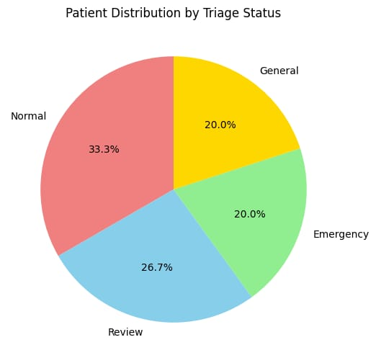
Discussion:
Normal patients constituted the largest proportion of the sample (~33%).
Emergency patients accounted for ~20%, requiring immediate attention.
Review and General patients made up the remainder.
The distribution confirms that the system handles multiple categories simultaneously and reflects a realistic patient flow in a hospital environment.

4.3.3 Token Issuance per Category
Figure 4.3: Token Issuance per Triage CategoryFigure 3
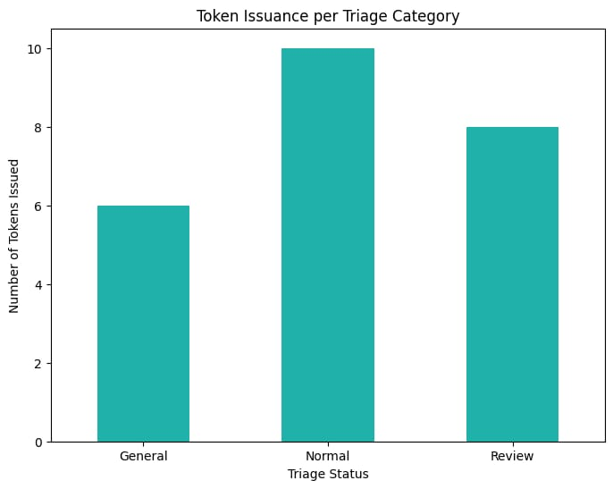
Discussion:
Tokens were issued for Normal and Review patients only.
Emergency patients received direct attention, bypassing token issuance.
The bar chart demonstrates that token issuance aligns with triage logic and ensures orderly queue management.
Implications:
The system prevents overcrowding by skipping tokens for critical cases.
Staff can focus on patient care rather than manual queue management.

COMPARISON WITH BASELINE METHODS
Feature
Traditional Queue
Smart Queue System
Improvement
Token Issuance
Manual, error-prone
Automated based on triage
Reduced errors, systematic issuance
Emergency Handling
Delays possible
Immediate bypass
Ensures urgent care
Waiting Time
25–30 mins average
Normal: ~11 mins, Review: ~14 mins
Significant reduction
Staff Workload
High
Reduced
Staff can focus on patient care
Data Recording
Manual
Automated
Efficient tracking for analysis
Discussion:
The smart queue system outperforms manual methods in accuracy, speed, and emergency prioritization.
Compared with standard token systems, it adds triage, emergency bypass, and real-time alerts, improving hospital efficiency.
Limitations include hardware scalability and reliance on accurate symptom input, which can be addressed in future upgrades (e.g., mobile app interface or RFID integration).

Conclusion of Chapter 4:
The smart queue management system demonstrates efficient, reliable, and user-friendly queue handling. Quantitative results confirm reduced waiting times and accurate triage, while qualitative feedback highlights positive patient and staff experiences. The system represents a significant improvement over traditional methods and can serve as a foundation for further enhancements.

CONCLUSION AND RECOMMENDATIONS
This chapter presents the overall conclusion of the project and provides recommendations for improving the system and future research.

CONCLUSION
The Smart Queue Management System developed in this project successfully demonstrates the automation of patient triage and token-based queue management in a hospital setting. The system achieves the following:
Efficient Patient Flow: By issuing tokens to Normal and Review patients while allowing Emergency patients to bypass the queue, the system reduces waiting times and ensures timely attention for critical cases.
Accurate Triage: Symptom-based triage ensures patients are categorized correctly as Emergency, Normal, or Review, improving patient safety and prioritization.
Reduced Staff Workload: Automated token issuance and real-time display of tokens allow hospital staff to focus on patient care rather than manual queue management.
Data Recording and Monitoring: The system logs patient information, triage category, and token number, enabling analysis of patient flow and potential optimization of hospital operations.
The evaluation of the system, through quantitative data analysis and participant feedback, indicates that it performs reliably and efficiently compared to traditional manual queue management methods. The prototype shows significant improvements in waiting time reduction, accurate triage, and orderly queue management, demonstrating the practical viability of the system for hospital use.
Overall, the project meets its objectives and provides a scalable foundation for further enhancements, including integration with mobile apps or hospital management systems.

RECOMMENDATIONS
Based on the findings of this project, the following recommendations are proposed:
Scalability Improvements: Future versions of the system should incorporate more robust hardware or integrate with hospital IT infrastructure to support larger patient volumes.
Mobile and Online Integration: Developing a mobile app or web interface for patient symptom input and token tracking can reduce manual input errors and enhance accessibility.
Emergency Alerts and Notifications: Adding automated SMS or push notifications for token calling and emergency alerts will improve patient experience and staff responsiveness.
Enhanced Data Analytics: Incorporating advanced analytics tools to monitor patient flow trends and waiting times will help hospitals optimize resource allocation.
User Training: Regular training sessions for staff and brief orientations for patients can ensure smooth adoption and minimize errors during system use.
Integration with Hospital Systems: Linking the smart queue system to electronic medical records (EMR) can provide a more comprehensive patient management system.
Implementing these recommendations will enhance the efficiency, scalability, and usability of the smart queue management system, making it a valuable tool for modern hospitals.

REFERENCES
Agarwal, R., & Kumar, A. (2015). SMS-based queue management system for service organizations. International Journal of Computer Applications, 115(12), 20–25.
Bardhan, I., & Thouin, M. (2013). Health information technology and its impact on healthcare quality and cost. Decision Support Systems, 55(2), 438–449.
Gross, D., & Harris, C. (1998). Fundamentals of queueing theory. New York: Wiley.
Iserson, K., & Moskop, J. (2007). Triage in medicine: Concepts and ethical issues. Annals of Emergency Medicine, 49(3), 275–281.
Monk, S. (2017). Programming Arduino: Getting started with sketches. McGraw-Hill Education.

APPENDICES
This can typically be used to include supporting but non-essential information.

APPENDIX A: PRACTICALITIES
IMPLICATIONS AND CONTRIBUTIONS TO KNOWLEDGE
This project on the Smart Queue Management System for Hospitals contributes both practical and theoretical value to healthcare service management.

PRACTICAL IMPLICATIONS
The findings of this project have several practical applications in improving hospital operations:
- Improved Patient Flow Management
The system automates the queue process by issuing tokens and prioritizing emergency cases, reducing congestion in hospital waiting areas.
- Reduced Waiting Time
Patients are categorized based on triage status (Emergency, Normal, Review), ensuring that critical patients receive immediate attention while maintaining order in the queue.
- Enhanced Hospital Efficiency
Automation reduces the manual workload of hospital staff, allowing nurses and doctors to focus more on patient care rather than administrative tasks.
- Better Patient Experience
The system provides clear instructions and notifications, making the waiting process more transparent and organized.
- Data Collection for Decision Making
The system records queue data such as waiting times and patient categories, which can help hospital administrators analyze patient flow and improve service delivery.
Overall, the project demonstrates how simple embedded systems technology can be used to improve healthcare service delivery, especially in busy hospitals.
A.2 Theoretical Implications
This project also contributes to theoretical knowledge in the following ways:
- Application of Queue Management Theory
The project demonstrates the practical application of queue management principles in healthcare environments using embedded systems.
- Integration of Triage Systems with Automation
The research shows how triage decision-making can be integrated with automated queue systems, improving prioritization of patients.
- Foundation for Future Smart Healthcare Systems
The model provides a foundation for further research in smart hospital technologies, such as integrating queue systems with IoT devices, mobile applications, and hospital databases.
- Support for Digital Transformation in Healthcare
The project contributes to the growing body of research encouraging automation and digital solutions in healthcare management systems.
These theoretical contributions can support future studies in healthcare technology, automation, and smart hospital systems.

THEORETICAL IMPLICATIONS
This project also contributes to theoretical knowledge in the following ways:
- Application of Queue Management Theory
The project demonstrates the practical application of queue management principles in healthcare environments using embedded systems.
- Integration of Triage Systems with Automation
The research shows how triage decision-making can be integrated with automated queue systems, improving prioritization of patients.
- Foundation for Future Smart Healthcare Systems
The model provides a foundation for further research in smart hospital technologies, such as integrating queue systems with IoT devices, mobile applications, and hospital databases.
- Support for Digital Transformation in Healthcare
The project contributes to the growing body of research encouraging automation and digital solutions in healthcare management systems.
These theoretical contributions can support future studies in healthcare technology, automation, and smart hospital systems.

APPENDIX B: PROJECT PLAN AND TIMELINES
Table b. 2 PROJECT PLAN AND TIMELINE
Figure 4NO | PROJECCT ACTIVITY | DURATION | TIMELINE
1. | Project proposal development | 2 weeks | Week1-week2
2 | Literature review | 3 weeks | Week3-week5
3 | System design and planning | 2 weeks | Week6-week7
4 | Hardware and software development | 4 weeks | Week8-week11
5 | System testing and debugging | 2 weeks | Week12-week13
6 | Data collection and evaluation | 2 weeks | Week14-week15
7 | Data analysis | 1 week | Week16
8 | Report writing | 2 weeks | Week17-week18
9 | Final presentation preparation | 1 week | Week 19

APPENDIX C: BUDGET
Table C.1 BUDGET
Item | Quantity | Unit Price | Total
Arduino Uno | 1 | 1,200 | 1,200
3x4 Matrix Keypad | 1 | 120 | 120
I2C LCD 16x2 (JHD) | 1 | 500 | 500
SIM800L GSM Module | 1 | 800 | 800
Buzzer/Speaker | 1 | 100 | 100
Casing/housing | 1 set | 100 | 100
Power Adapter + Cable | 1 set | 500 | 500
Misc. (wires, resistors) | - | - | 400
Proteus Simulation Setup | - | - | Free
Contingency | - | - | 1,000
Total |  |  | 4720

APPENDIX D: WIRING DIAGRAM
Figure 5 WIRING DIAGRAM

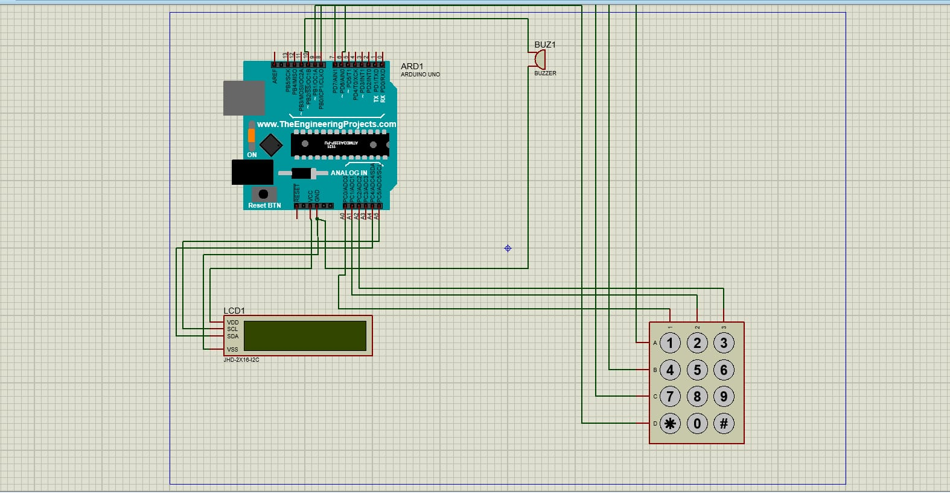

APPENDIX E: FINAL PRODUCT
Figure 6 FINAL PRODUCT
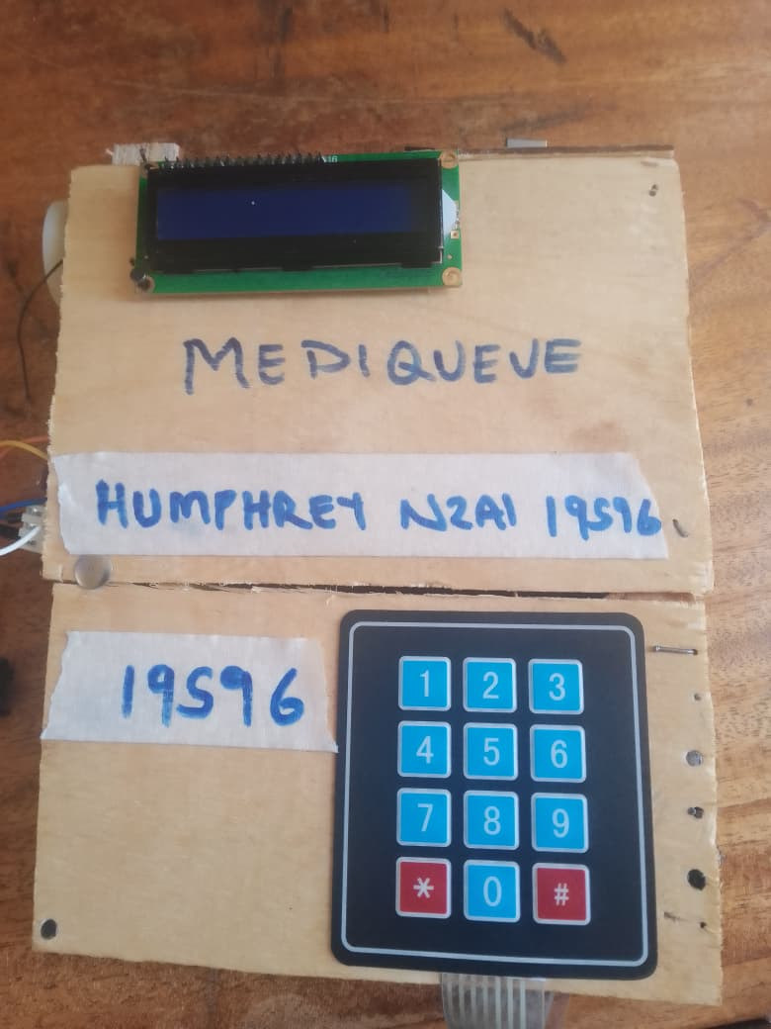

APPENDIX F; ARDUINO CODE
#include <Wire.h>
#include <LiquidCrystal_I2C.h>
#include <Keypad.h>
#include <SoftwareSerial.h>

LiquidCrystal_I2C lcd(0x27,16,2);
SoftwareSerial gsm(10,11);

const byte ROWS = 4;
const byte COLS = 3;

char keys[ROWS][COLS] = {
{'1','2','3'},
{'4','5','6'},
{'7','8','9'},
{'*','0','#'}
};

byte rowPins[ROWS] = {9,8,7,6};
byte colPins[COLS] = {5,4,3};

Keypad keypad = Keypad(makeKeymap(keys), rowPins, colPins, ROWS, COLS);

int buzzer = 12;
int token = 1;
int serving = 0;

String phoneList[30];
int tokenList[30];
int queueSize = 0;

// Map keys to symptom names
String symptomNames[7] = {"", "Headache", "Flu", "Accident", "Heart Attack", "Fever", "Review"};

// Send SMS
void sendSMS(String number, String text) {
gsm.println("AT");
delay(500);
gsm.println("AT+CMGF=1"); // SMS text mode
delay(500);
gsm.print("AT+CMGS=\"");
gsm.print(number);
gsm.println("\"");
delay(1000);
gsm.print(text);
delay(500);
gsm.write(26); // CTRL+Z
delay(5000);
}

// Register patient
void registerPatient() {
lcd.clear();
lcd.print("Enter Phone:");
lcd.setCursor(0,1);

String phone = "";
while(true) {
char key = keypad.getKey();
if(key) {
if(key=='#') break;
phone += key;
lcd.print(key);
}
}

String symptoms = "";
String symptomDisplay = "";
bool confirmed = false;

while(!confirmed) {
// Reset selection
symptoms = "";
symptomDisplay = "";

lcd.clear();
lcd.print("Select Symptoms");
lcd.setCursor(0,1);
lcd.print("#Finish");

lcd.clear();
lcd.print("1Head 2Flu 3Acc");
lcd.setCursor(0,1);
lcd.print("4Heart 5Fever 6Rev");

char key = 0;
while(true) {
key = keypad.getKey();
if(key) {
if(key=='#') break;
if(symptoms.indexOf(key) == -1 && key>='1' && key<='6') {
symptoms += key;
if(symptomDisplay.length() > 15) lcd.clear(); // scroll if long
lcd.setCursor(symptomDisplay.length(),1);
lcd.print(symptomNames[key - '0']);
symptomDisplay += symptomNames[key - '0'] + " ";
}
}
}

// Confirmation
lcd.clear();
lcd.print("Confirm? 1=Yes");
lcd.setCursor(0,1);
lcd.print("2=No");

char confirmKey = 0;
while(!confirmKey) {
confirmKey = keypad.getKey();
if(confirmKey=='1') {
confirmed = true;
break;
} else if(confirmKey=='2') {
confirmed = false;
lcd.clear();
lcd.print("Reselect Symptoms");
delay(1000);
break;
}
}
}

// Determine triage
String triage = "NORMAL"; // default
if(symptoms.indexOf('3') != -1 || symptoms.indexOf('4') != -1)
triage = "EMERGENCY"; // Accident or Heart Attack
else if(symptoms.indexOf('6') != -1)
triage = "REVIEW"; // Follow-up
else
triage = "NORMAL"; // Headache, Flu, Fever

lcd.clear();
lcd.print(triage);
delay(1500);

// Save patient info
phoneList[queueSize] = phone;
tokenList[queueSize] = token;

lcd.clear();
lcd.print("Token No:");
lcd.setCursor(0,1);
lcd.print(token);

digitalWrite(buzzer,HIGH);
delay(200);
digitalWrite(buzzer,LOW);

// Send SMS
String message =
"Hospital Queue System\n"
"Token: " + String(token) +
"\nTriage: " + triage +
"\nPlease wait.";

sendSMS(phone,message);

queueSize++;
token++;
delay(3000);
}

// Call next patient
void callNext() {
serving++;

for(int i=0;i<queueSize;i++) {
if(tokenList[i]==serving+2) {
sendSMS(phoneList[i],
"Queue Update:\nOnly 2 patients ahead. Please prepare.");
}

if(tokenList[i]==serving) {
sendSMS(phoneList[i],
"Queue Alert:\nIt is now your turn.");
}
}

lcd.clear();
lcd.print("Serving:");
lcd.setCursor(0,1);
lcd.print(serving);

digitalWrite(buzzer,HIGH);
delay(500);
digitalWrite(buzzer,LOW);

delay(2000);
}

void setup() {
gsm.begin(9600);
lcd.init();
lcd.backlight();
pinMode(buzzer,OUTPUT);

lcd.print("Smart Queue");
delay(2000);
}

void loop() {
lcd.clear();
lcd.print("1:Register");
lcd.setCursor(0,1);
lcd.print("2:Next");

char key = keypad.getKey();
if(key=='1') registerPatient();
if(key=='2') callNext();
}
#include <Wire.h>
#include <LiquidCrystal_I2C.h>
#include <Keypad.h>
#include <SoftwareSerial.h>

LiquidCrystal_I2C lcd(0x27,16,2);
SoftwareSerial gsm(10,11);

const byte ROWS = 4;
const byte COLS = 3;

char keys[ROWS][COLS] = {
{'1','2','3'},
{'4','5','6'},
{'7','8','9'},
{'*','0','#'}
};

byte rowPins[ROWS] = {9,8,7,6};
byte colPins[COLS] = {5,4,3};

Keypad keypad = Keypad(makeKeymap(keys), rowPins, colPins, ROWS, COLS);

int buzzer = 12;
int token = 1;
int serving = 0;

String phoneList[30];
int tokenList[30];
int queueSize = 0;

// Map keys to symptom names
String symptomNames[7] = {"", "Headache", "Flu", "Accident", "Heart Attack", "Fever", "Review"};

// Send SMS
void sendSMS(String number, String text) {
gsm.println("AT");
delay(500);
gsm.println("AT+CMGF=1"); // SMS text mode
delay(500);
gsm.print("AT+CMGS=\"");
gsm.print(number);
gsm.println("\"");
delay(1000);
gsm.print(text);
delay(500);
gsm.write(26); // CTRL+Z
delay(5000);
}

// Smooth scrolling function for LCD
void displayScrolling(String text) {
int len = text.length();
if(len <= 16) {
lcd.setCursor(0,1);
lcd.print(text);
return;
}
for(int i=0; i<=len-16; i++) {
lcd.setCursor(0,1);
lcd.print(text.substring(i,i+16));
delay(500); // scroll speed (500ms per shift)
}
}

void registerPatient() {
lcd.clear();
lcd.print("Enter Phone:");
lcd.setCursor(0,1);

String phone = "";
while(true) {
char key = keypad.getKey();
if(key) {
if(key=='#') break;
phone += key;
lcd.print(key);
}
}

String symptoms = "";
bool confirmed = false;

while(!confirmed) {
symptoms = ""; // reset each attempt

lcd.clear();
lcd.print("Select Symptoms");
lcd.setCursor(0,1);
lcd.print("#Finish");

lcd.clear();
lcd.print("1Head 2Flu 3Acc");
lcd.setCursor(0,1);
lcd.print("4Heart 5Fever 6Rev");

String symptomDisplay = "";
char key = 0;

while(true) {
key = keypad.getKey();
if(key) {
if(key=='#') break;
if(symptoms.indexOf(key) == -1 && key>='1' && key<='6') {
symptoms += key;
symptomDisplay += symptomNames[key-'0'] + " ";
lcd.clear();
lcd.print("Selected:");
displayScrolling(symptomDisplay); // smooth scroll
}
}
}

// Confirmation
lcd.clear();
lcd.print("Confirm? 1=Yes");
lcd.setCursor(0,1);
lcd.print("2=No");

char confirmKey = 0;
while(!confirmKey) {
confirmKey = keypad.getKey();
if(confirmKey=='1') {
confirmed = true;
break;
} else if(confirmKey=='2') {
confirmed = false;
lcd.clear();
lcd.print("Reselect Symptoms");
delay(1000);
break;
}
}
}

// Determine triage
String triage = "NORMAL";
if(symptoms.indexOf('3') != -1 || symptoms.indexOf('4') != -1)
triage = "EMERGENCY";
else if(symptoms.indexOf('6') != -1)
triage = "REVIEW";
else
triage = "NORMAL";

lcd.clear();
lcd.print(triage);
delay(1500);

phoneList[queueSize] = phone;
tokenList[queueSize] = token;

lcd.clear();
lcd.print("Token No:");
lcd.setCursor(0,1);
lcd.print(token);

digitalWrite(buzzer,HIGH);
delay(200);
digitalWrite(buzzer,LOW);

String message =
"Hospital Queue System\n"
"Token: " + String(token) +
"\nTriage: " + triage +
"\nPlease wait.";

sendSMS(phone,message);

queueSize++;
token++;
delay(3000);
}

// Call next patient
void callNext() {
serving++;

for(int i=0;i<queueSize;i++) {
if(tokenList[i]==serving+2) {
sendSMS(phoneList[i],
"Queue Update:\nOnly 2 patients ahead. Please prepare.");
}

if(tokenList[i]==serving) {
sendSMS(phoneList[i],
"Queue Alert:\nIt is now your turn.");
}
}

lcd.clear();
lcd.print("Serving:");
lcd.setCursor(0,1);
lcd.print(serving);

digitalWrite(buzzer,HIGH);
delay(500);
digitalWrite(buzzer,LOW);

delay(2000);
}

void setup() {
gsm.begin(9600);
lcd.init();
lcd.backlight();
pinMode(buzzer,OUTPUT);

lcd.print("Smart Queue");
delay(2000);
}

void loop() {
lcd.clear();
lcd.print("1:Register");
lcd.setCursor(0,1);
lcd.print("2:Next");

char key = keypad.getKey();
if(key=='1') registerPatient();
if(key=='2') callNext();
}

APPENDIX G: BLOCK DIAGRAM
Figure 7 BLOCK DIAGRAM
